TASK 3-

* Construct a branch, do some changes in the branch, and merge it with master (or trunk)

Step -1 Initialize repo and make first commit

git init

echo”First commit file”> readme.txt

git commit -m “Initial commit”

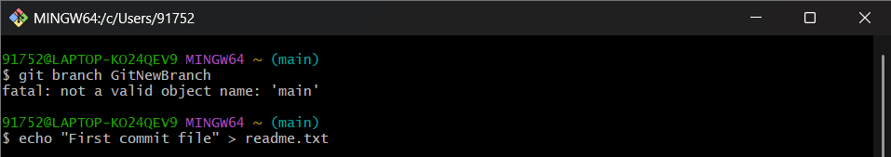

Step -2 Create and list branches

git branch GitNewBranch

git branch

Step -3 **Switch to new branch and add changes** bash

**git checkout GitNewBranch**

**echo "Some changes in new branch" > branchfile.txt**

**git add branchfile.txt**

**git commit -m "Added branchfile.txt in GitNewBranch"**

**git status**

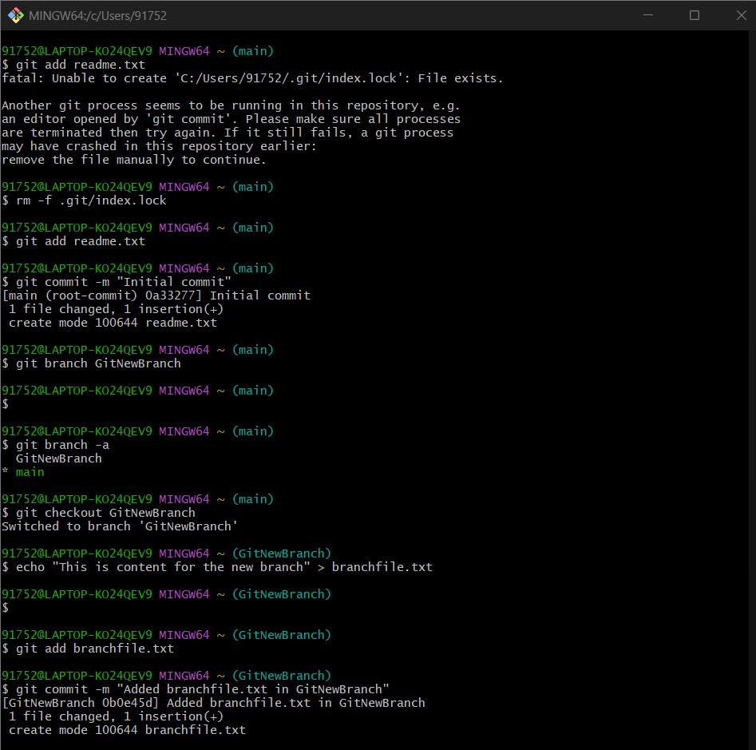

Step 4- Switch back to main branch

git checkout main

Step 5- Show differences between main and branch

git diff main GitNewBranch

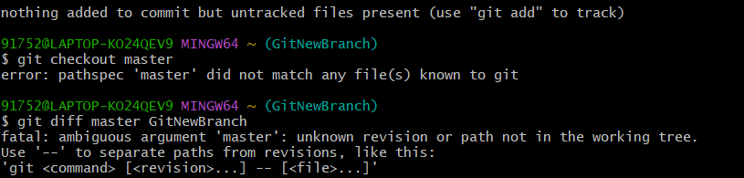

Step 6-Show visual differences with P4Merge

git mergetool

Step 7- Merge the branch into main

git merge GitNewBranch

